

Build Image từ dockerfile

=> docker build -t tuannl/gatewayapi:latest -f .\ApiGateway\WebApiGateway\Dockerfile .

=> docker build -t tuannl/portfolioapi:latest -f .\Services\PortfolioManagement\PortfolioApi\Dockerfile .

=> docker build -t tuannl/accountapi:latest -f .\Services\System\Accounts.API\Dockerfile .

=> docker push tuannl/gatewayapi:latest

=> docker push tuannl/accountapi:latest

=> docker push tuannl/portfolioapi:latest

sudo docker run --name docker-nginx -p 80:80 -v /home/devteam/fundweb/html:/usr/share/nginx/html nginx -v /home/devteam/fundweb/nginxconfig:/etc/nginx/conf.d/default.conf -d nginx

docker exec -it docker-nginx bash

Cloud

Pull

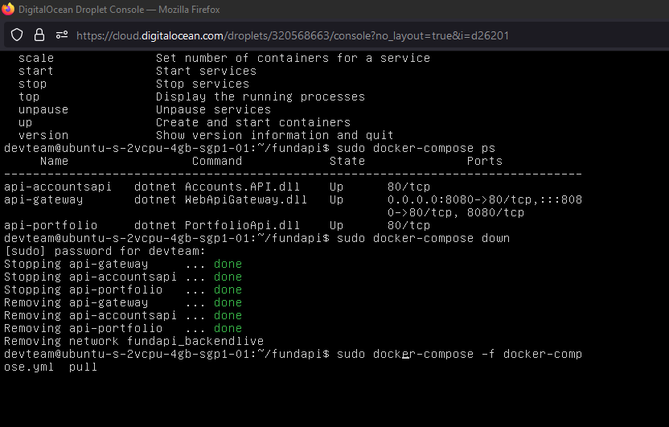

Up

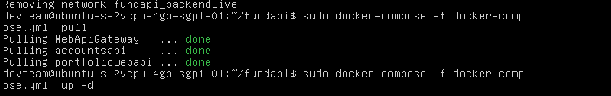

TaxFee Scirpt

INSERT INTO public."TaxFee"(

"TaxFeeId", "TaxFeeName", "ValueDate", "TaxRate", "FeeRate", "CreatedUser", "CreateDate", "UpdateUser", "UpdateDate", "Status", "RecordNo", "ApprovedUser", "ApprovedDate", "IsActive")

VALUES ('TaxFee02','Thue phi 2', now() ,3000, 40000, 'tuannl11',now(),'',now(), 'A',0,'',now(), true);

# Goi tao ma transacion

DO

$$

DECLARE transNo varchar;

v_dealtype int := 1;

v_dealdate TIMESTAMP:=now();

v_IsView boolean :=true;

BEGIN

CALL createtransactionnewno(v_dealtype, v_dealdate,v_IsView,transNo);

RAISE NOTICE '%', transNo;

END;

$$

--SELECT last_value FROM public.transaction_buy_seq;

# Exec tao giao dich

DO

$$

DECLARE v_transactionno character varying(20):='';

v_transactiondate timestamp :=now();

v_portfolioid character(20):='HOC001 ';

v_assetid character(20):='1 ';

v_dealtype integer:=1; -- 1: BUY, -1 SELL

v_valuedate timestamp :=now();

v_paymentdate timestamp :=now();

v_transactionamount numeric(25,6):=1000000;

v_transactionprice numeric(25,6):=10000;

v_transactionvalue numeric(25,6):=100000000;

v_taxfeeid character(20):='TaxFee03 ';

v_taxamount numeric(25,6):=1000;

v_feeamount numeric(25,6):=2000;

v_note text :='test';

v_createduser text:='tuannl';

resultcode integer;

BEGIN

CALL public.inserttransaction(

v_transactionno ,

v_transactiondate,

v_portfolioid ,

v_assetid ,

v_dealtype ,

v_valuedate ,

v_paymentdate ,

v_transactionamount,

v_transactionprice ,

v_transactionvalue ,

v_taxfeeid,

v_taxamount ,

v_feeamount ,

v_note ,

v_createduser ,

resultcode );

RAISE NOTICE '%', v_transactionno;

END;

$$